Problem 1 Binomial vs. Poisson Distribution

I have 10 chairs available per table at a charity fundraiser. I only have 5 people that purchased tickets for the high-dollar table with the celebrity speaker.

- How many different ways can I seat these 5 people if it matters who sits where (closer to the speaker, for example)?

This is a permutation problem:

¹⁰P₅ = $\frac{10!}{(10-5)!}$ = 30240

- How many different ways can I seat these 5 people if it doesn’t matter who sits where?

This is a combination problem:

¹⁰C₅ = $\frac{10!}{5!(10-5)!}$ = 252

- Explain how part b) is analogous to the random walk example we talked about in class? Why is order not important in the random walk? Think about the people showing up as bringing money to the event. See part d) below.

Combination does not respect order, and so does random walk not consider direction.

- Looking now over the whole venue, there are 100 tables with 10 chairs each. I have sold every ticket, but I have used all these ticket sales to pay for the celebrity speaker. Let’s say that there is a probability of 80% that someone who purchased a ticket to the event will show up. For every person that shows up, I will make $100 on average in additional fundraising from auctions, raffles, etc. For every person that does not show up, I will lose $100 in food and hall rental costs. What is the chance that I will make a profit on this fundraiser?
The probability that a person turns up is p = 0.8, and the probability that they do not is q = 0.2. This is a binomial problem with n = 10*100 = 1000. Profit is made if x > 500, this is solved using a cumulative probability function.

P(x > 500) = $\sum_{x=500}^{1000}{1000Cx{0.8}^{x}{0.2}^{1000-x}}$ < 0.0001

- Plot the probability density function (pdf) for this event as probability vs.
attendees.
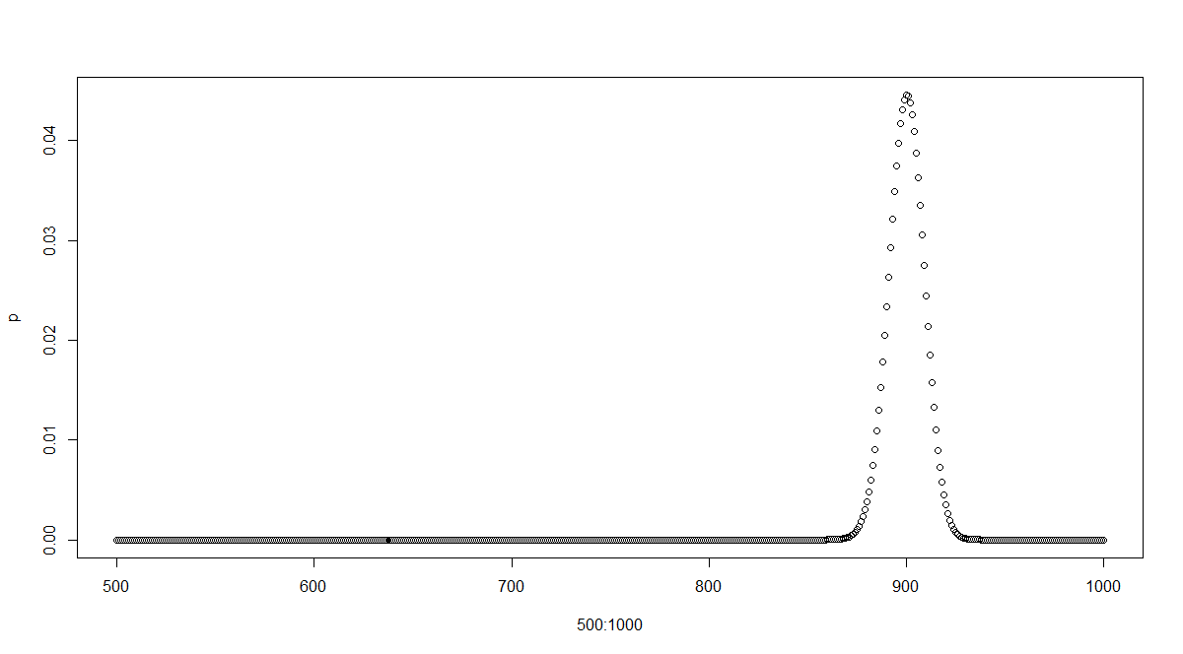

- Show that the Poisson Distribution is a bad approximation for this probability distribution.
The poisson distribution is not a good approximator because p = 0.8 is large and n = 1000 gives a lambda of 800, which is too large.

- Show how the Poisson Distribution is a good approximation for this event if the probability of showing up after purchasing a ticket is 99%. It is a celebrity speaker after all.

The Poisson distribution gives lamda = 0.99*1000 = 990

This gives a probability of 0.00112

Problem 2 Monte Carlo simulation

Suppose you have the choice of investing in three assets with the following statistics:

Expected Returns
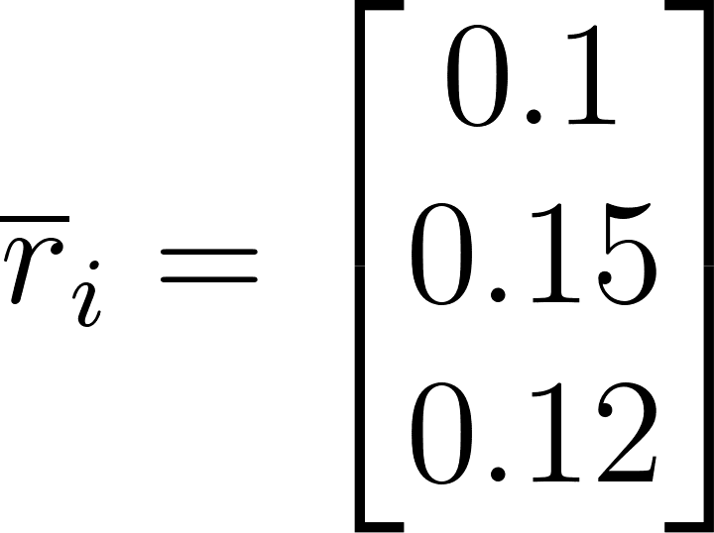
Standard Deviations
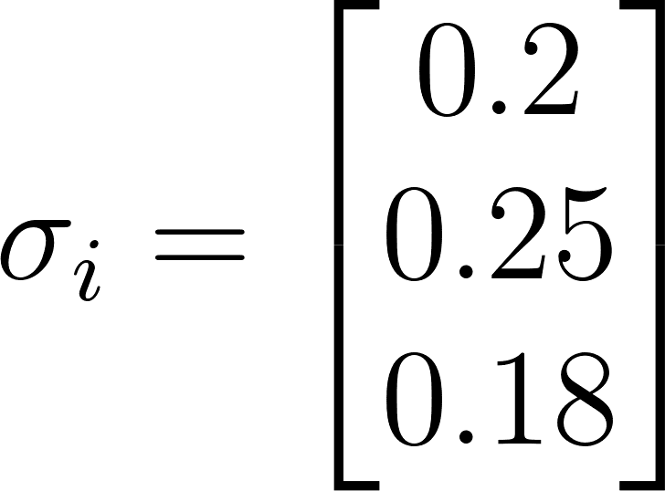
Correlations
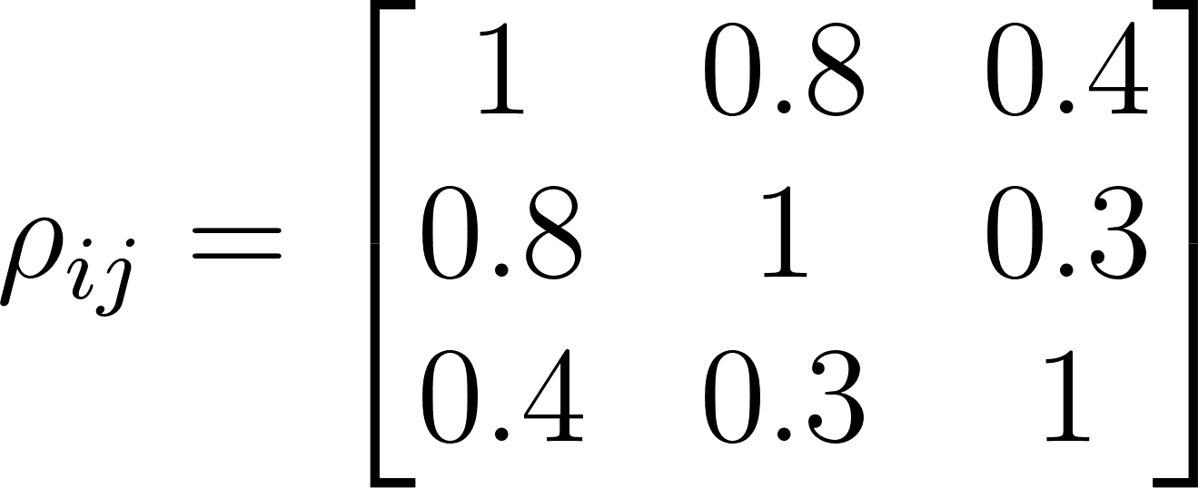
Plot 1000 random portfolios that will make up the space of feasible solutions.
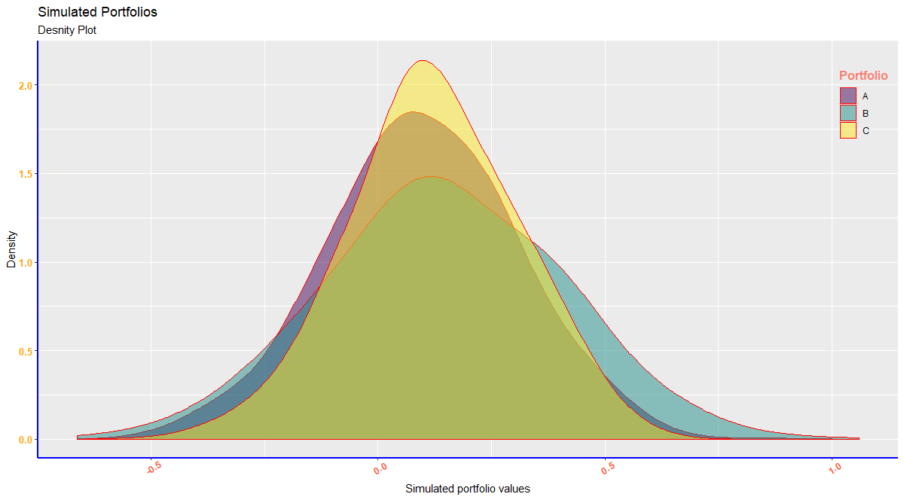
Upload your code in MATLAB, Python, etc.… that does the following steps:
- Create V, the variance \ covariance matrix using the statistics given above. You can do this step by hand if you prefer.

V = $\begin{matrix}{0.2}^{2} \\ {0.25}^{2} \\ {0.18}^{2}\end{matrix}$ = $\begin{matrix}0.04 \\ 0.0625 \\ 0.0324\end{matrix}$

- Create three random numbers for each portfolio but normalize them so that they each add up to one, i.e. a feasible solution must add up to 100% of your total wealth available for investment. This step should probably be done in code.

First number = 0.4,
Second number = 0.2
Third number = 0.4

- Find the Expected Return of each portfolio.

First = 0.883
Second = 1.223
Third = 2.116
- Find the Variance of each portfolio

First = 0.22
Second = 0.123
Third = 0.224
- The standard deviation is the square root of the variance. Plot the portfolio returns vs. the standard deviation of these 1000 portfolios.
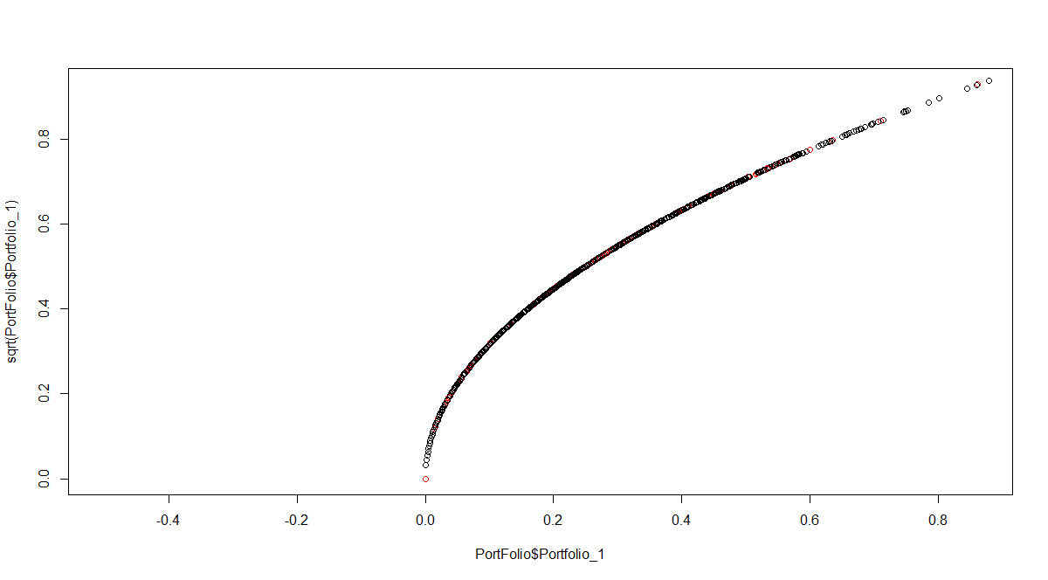
- Comment on the location of the efficient frontier that you see emerging from this graph. Note that you did not need to know anything about how to calculate it, the solution becomes very apparent using the power of Monte Carlo simulation.

The efficient frontier is located in the mid-point of the three portfolios.

